- Create one VPC in N. Virginia region.
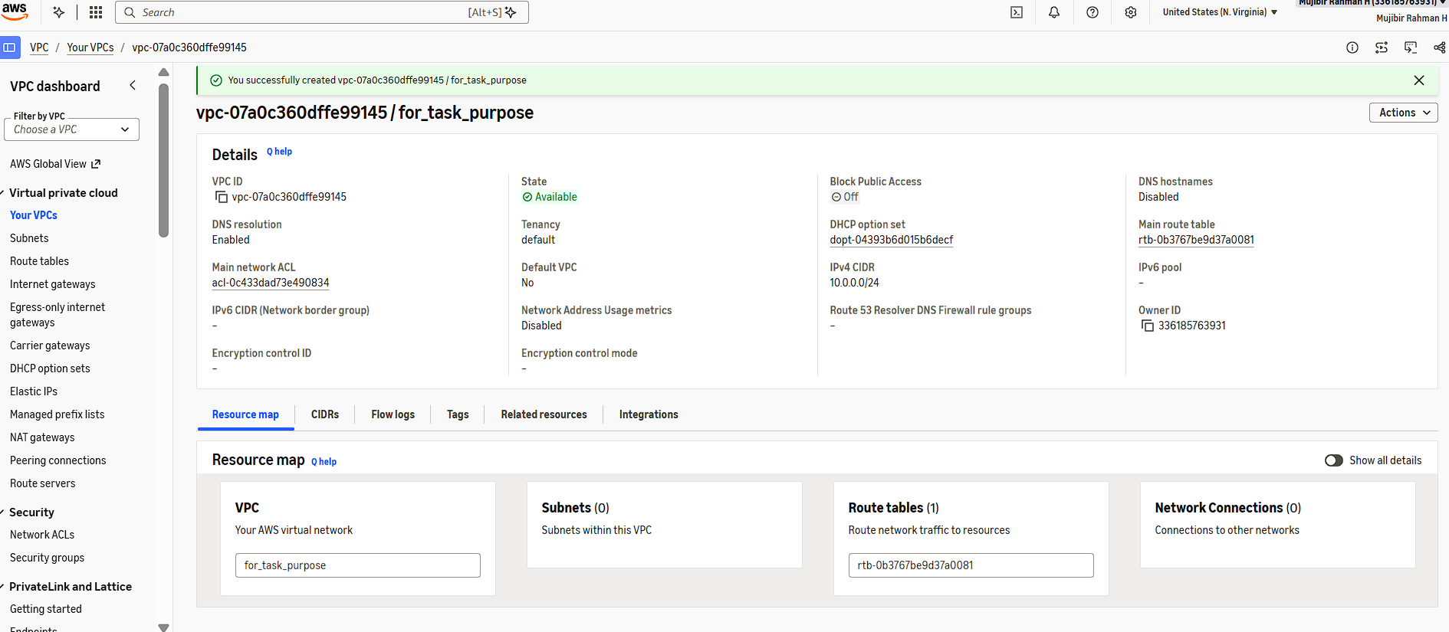
- Create two subnets: one public subnet and one private subnet.
We need to add the IGW into Route table, then only it called as a public subnet.
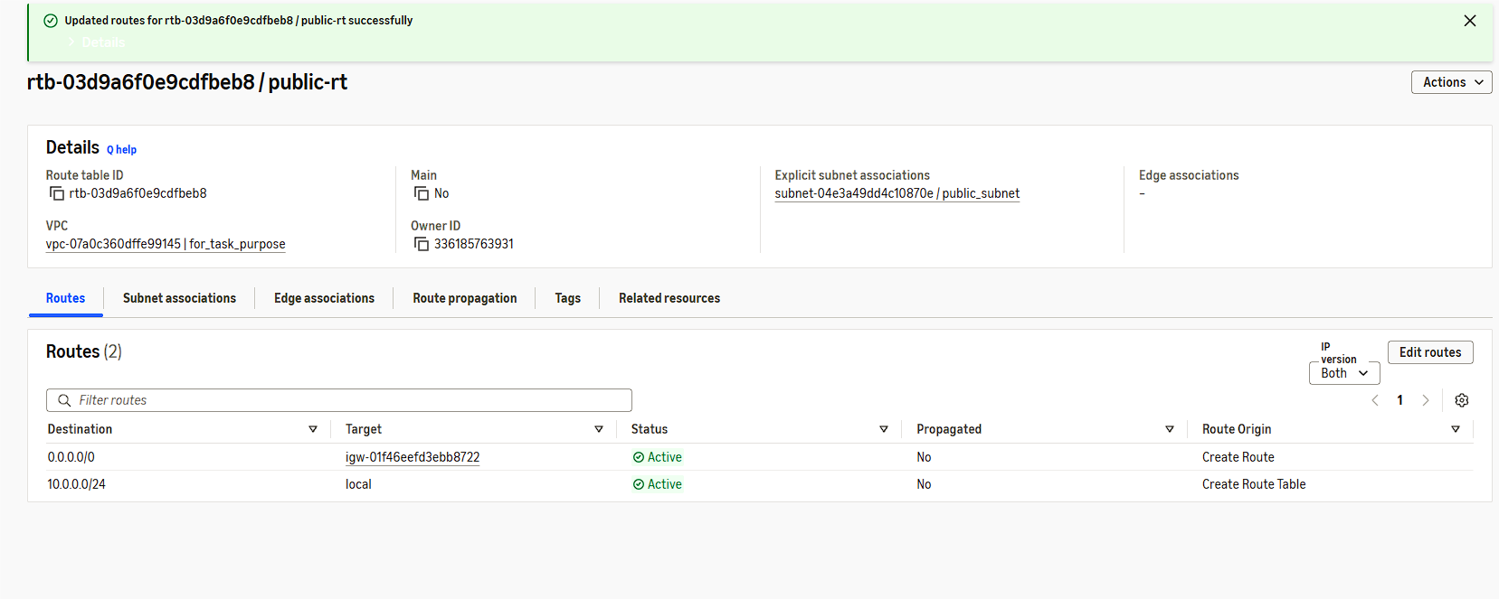
- Attach an IGW to the VPC.
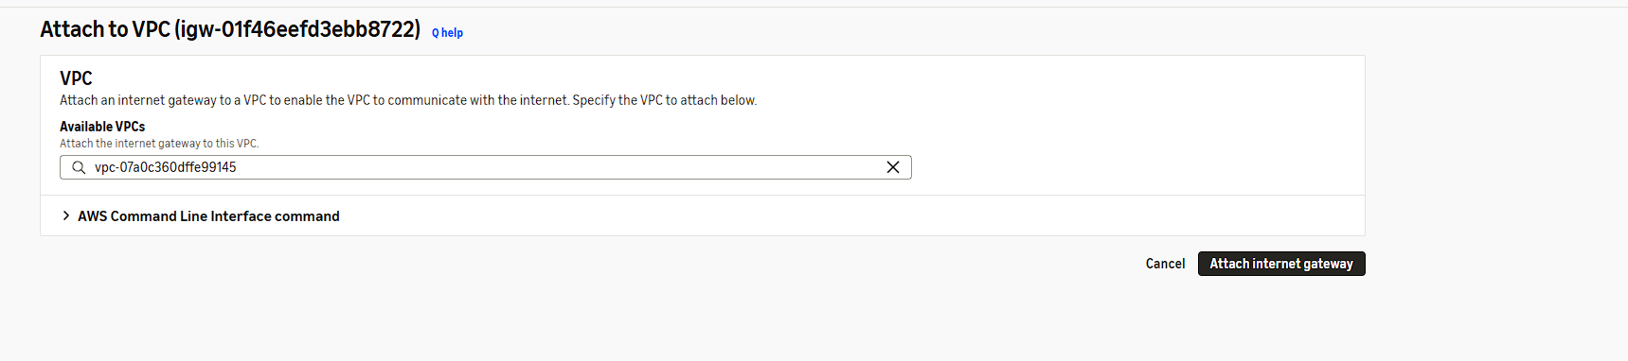
- Create one public route table (RT) and one private route table.
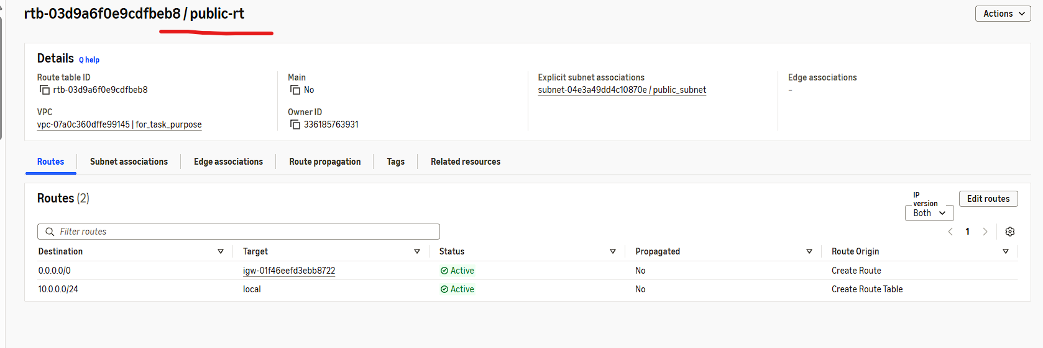
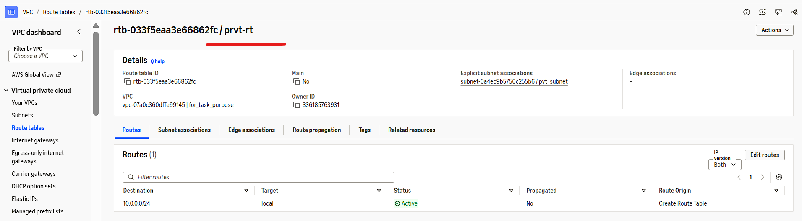
- Deploy a NAT gateway in the public subnet and attach the NAT gateway to the private subnet.
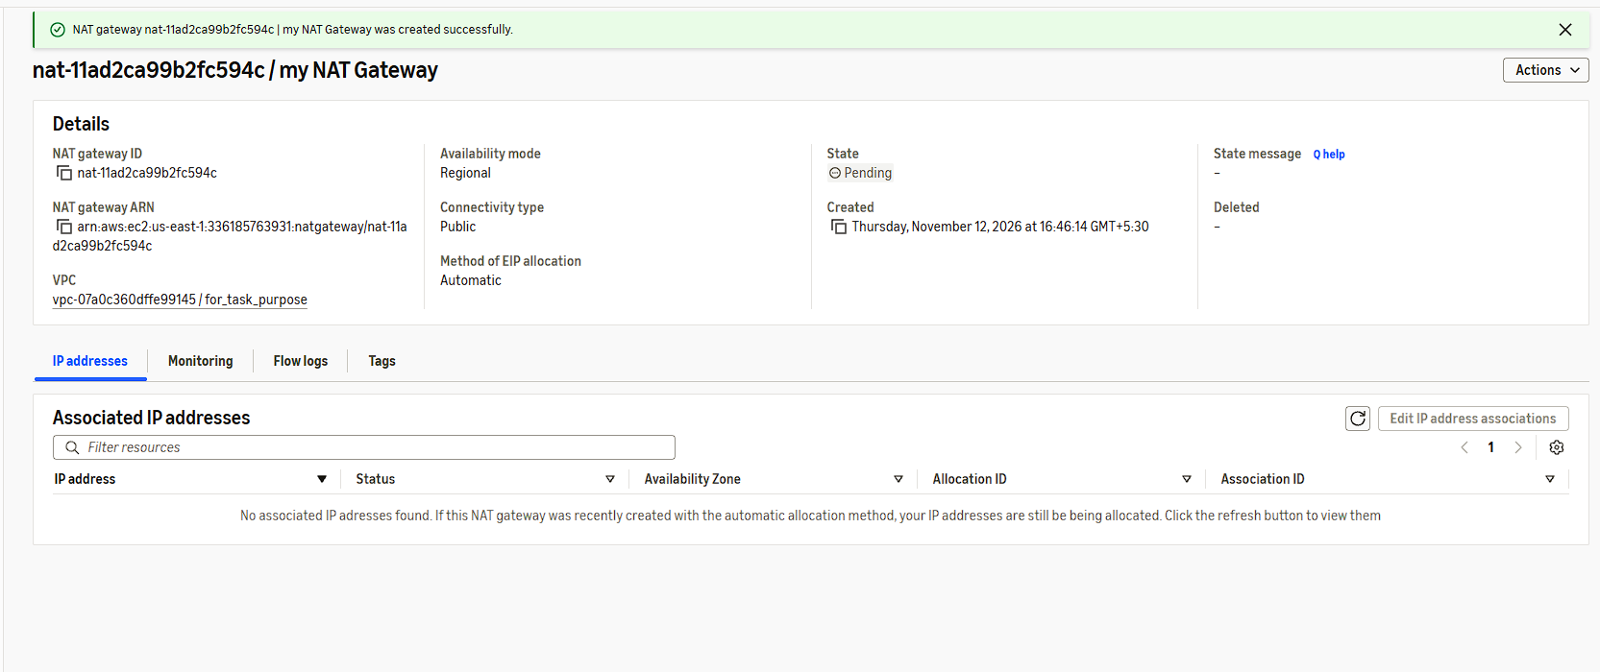
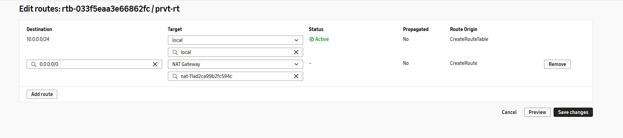
- Create two instances, one in the public subnet and one in the private subnet.
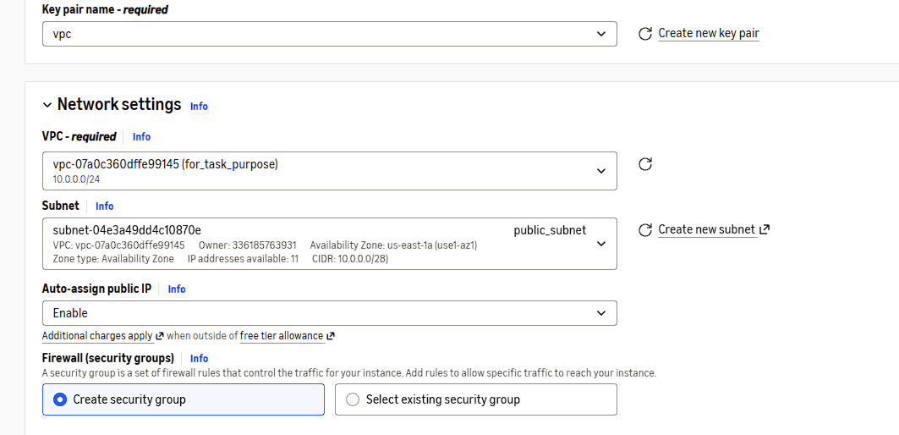
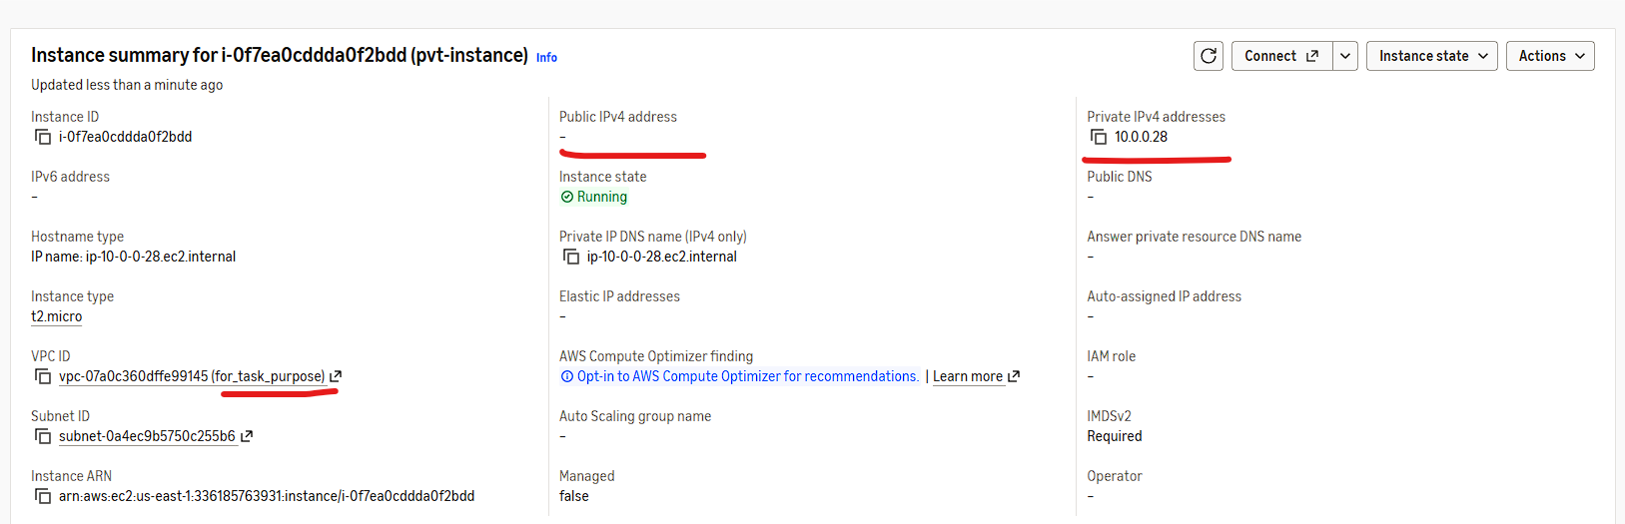
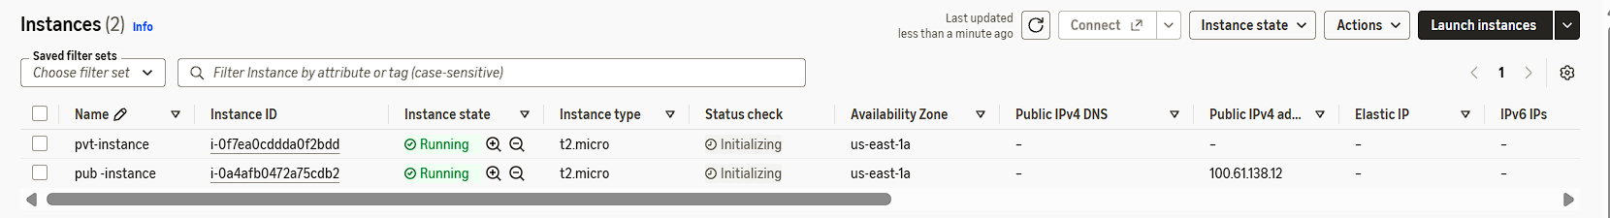
- Deploy Apache server on both EC2 instances with a sample index.html file.
I already launched the two instance. In that, I installed the apache httpd server manually.
I created custom index.html file in deployment path of httpd (Public server)
Did the same in private instance. But, I connected the private through jump host.
I used the IP address to see the web page which I created.
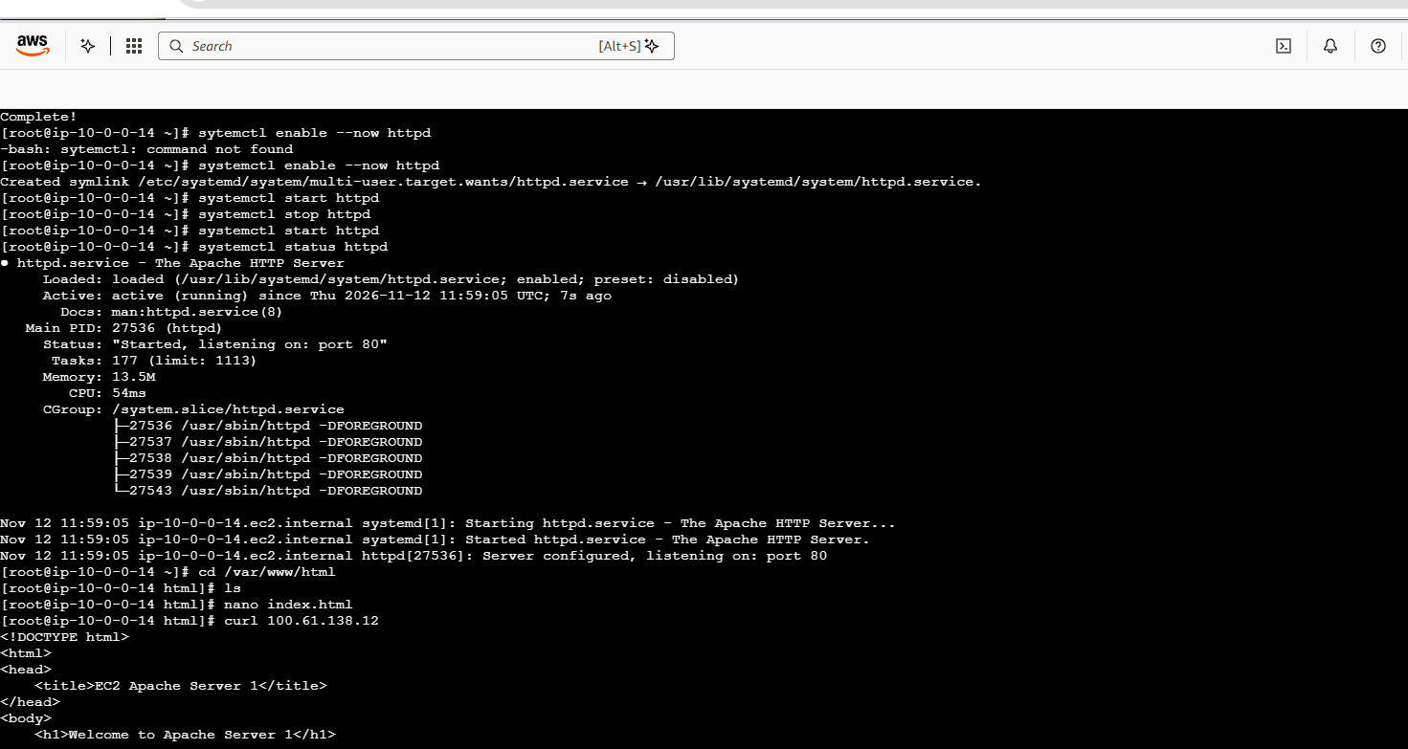
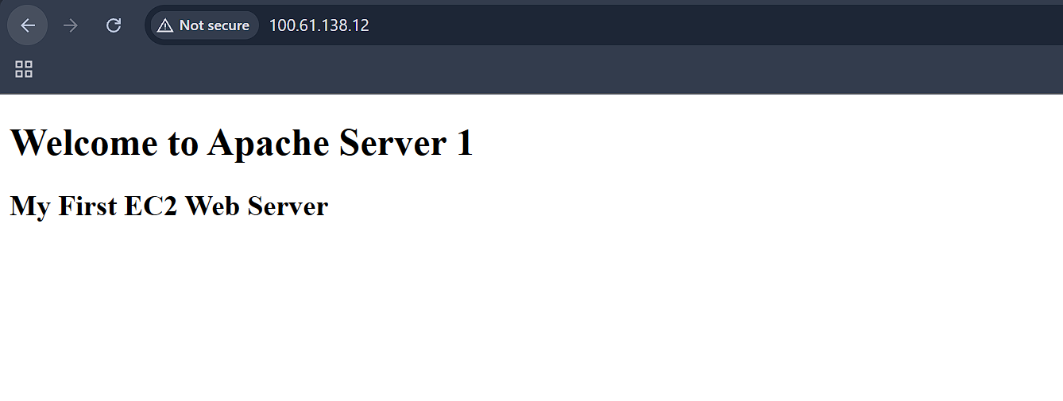
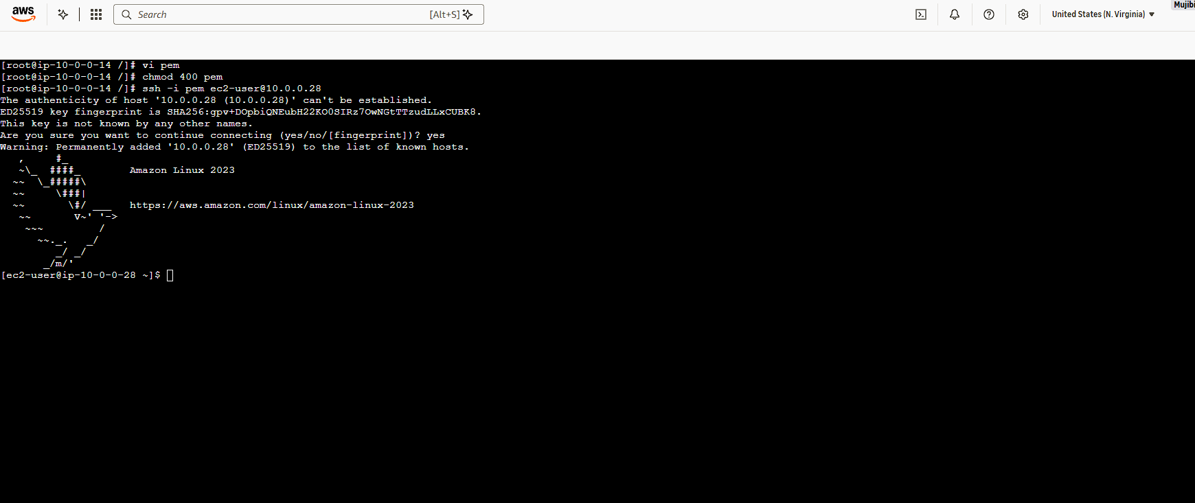
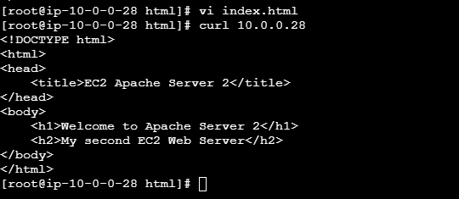
- Create one application load balancer and attach it to both EC2 instances.
We need to setup a Application load balancer. But pre requisite for that ALB is Target group.
So, First I created the Target group(Not much, Only the VPC and ports).
We need to have the two public subnet in one region but diff AZ’s. We need to select two public subnets while creating Load balancer.
Security group for inbound is so, Important. I faced a issue on that.
We need to configure the target in target group. That is also important.
At last, We are using the LB- DNS name to see the web age in browser.
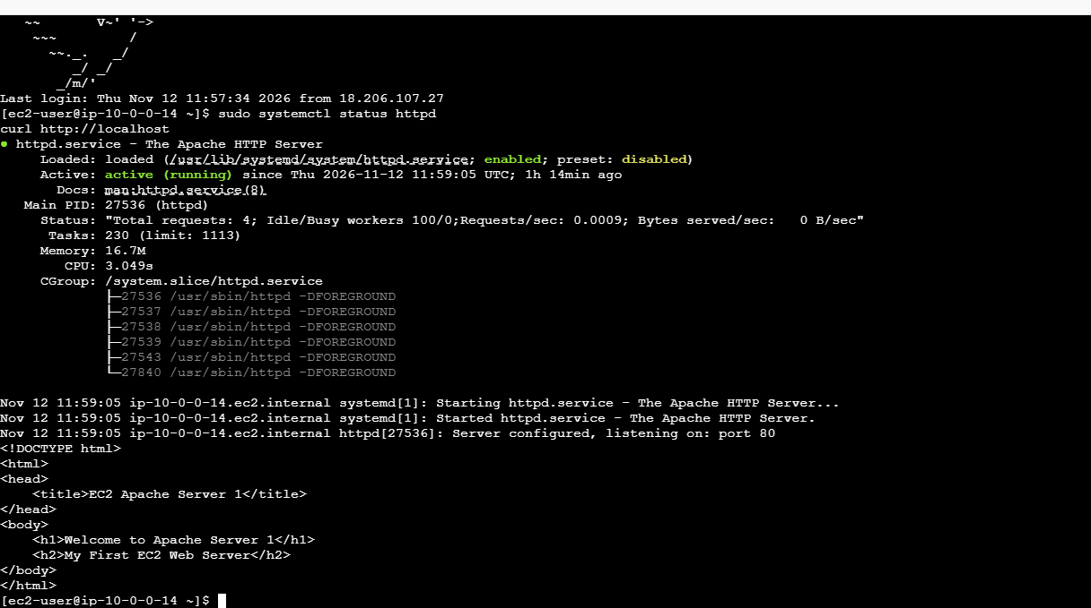
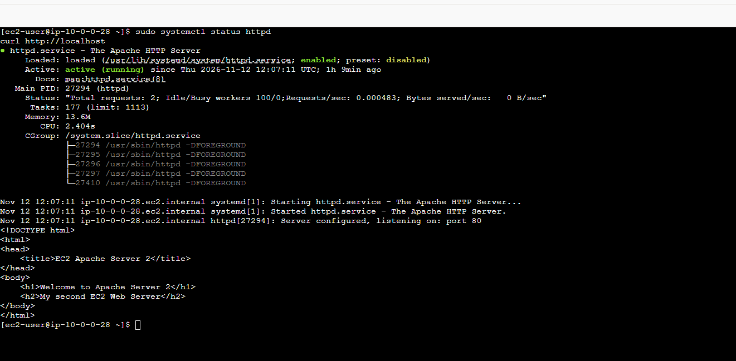
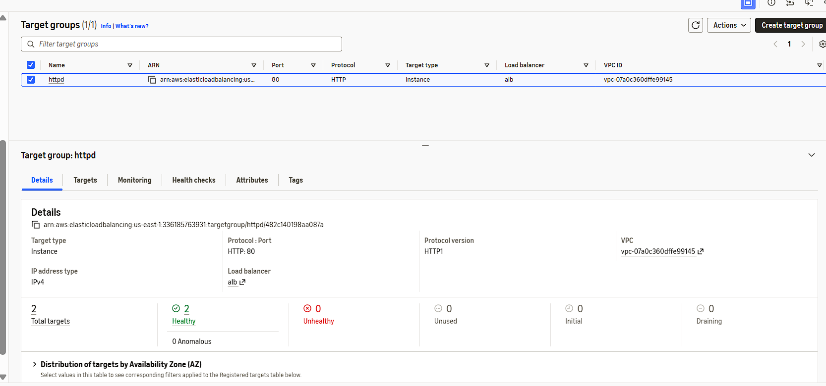
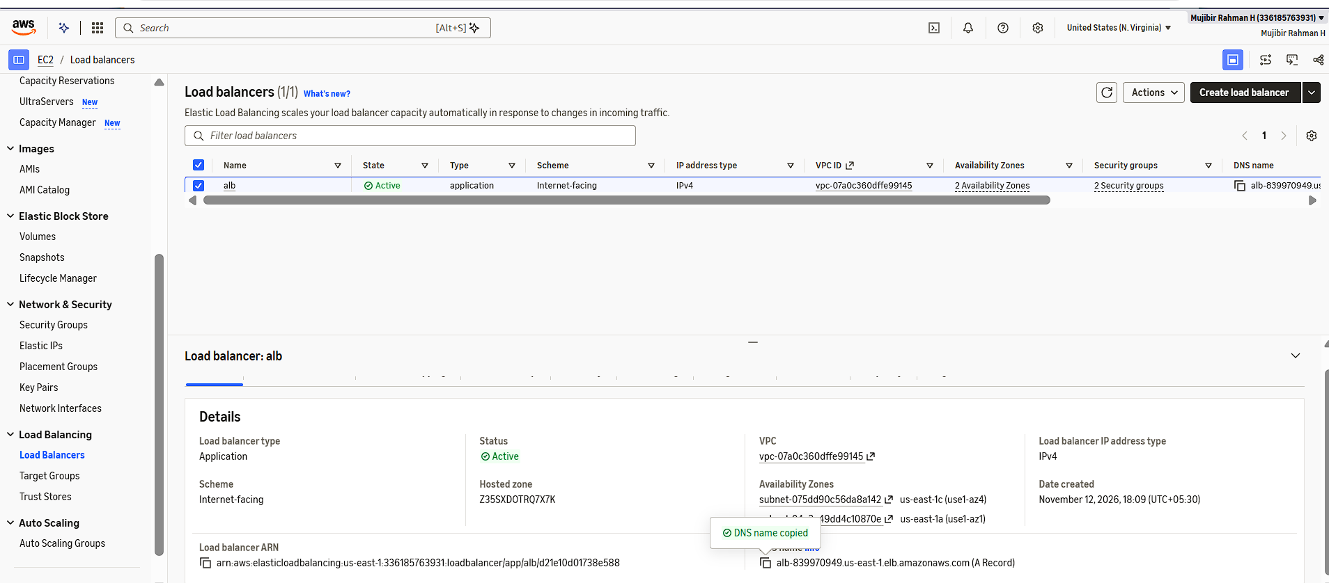
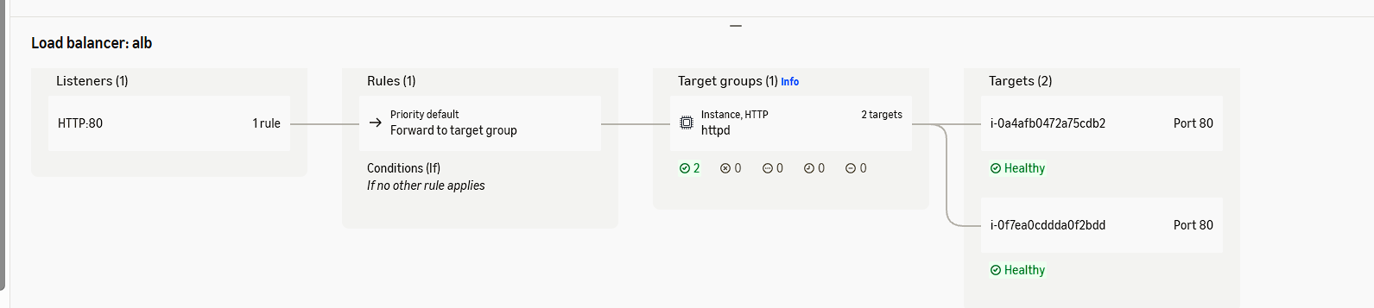
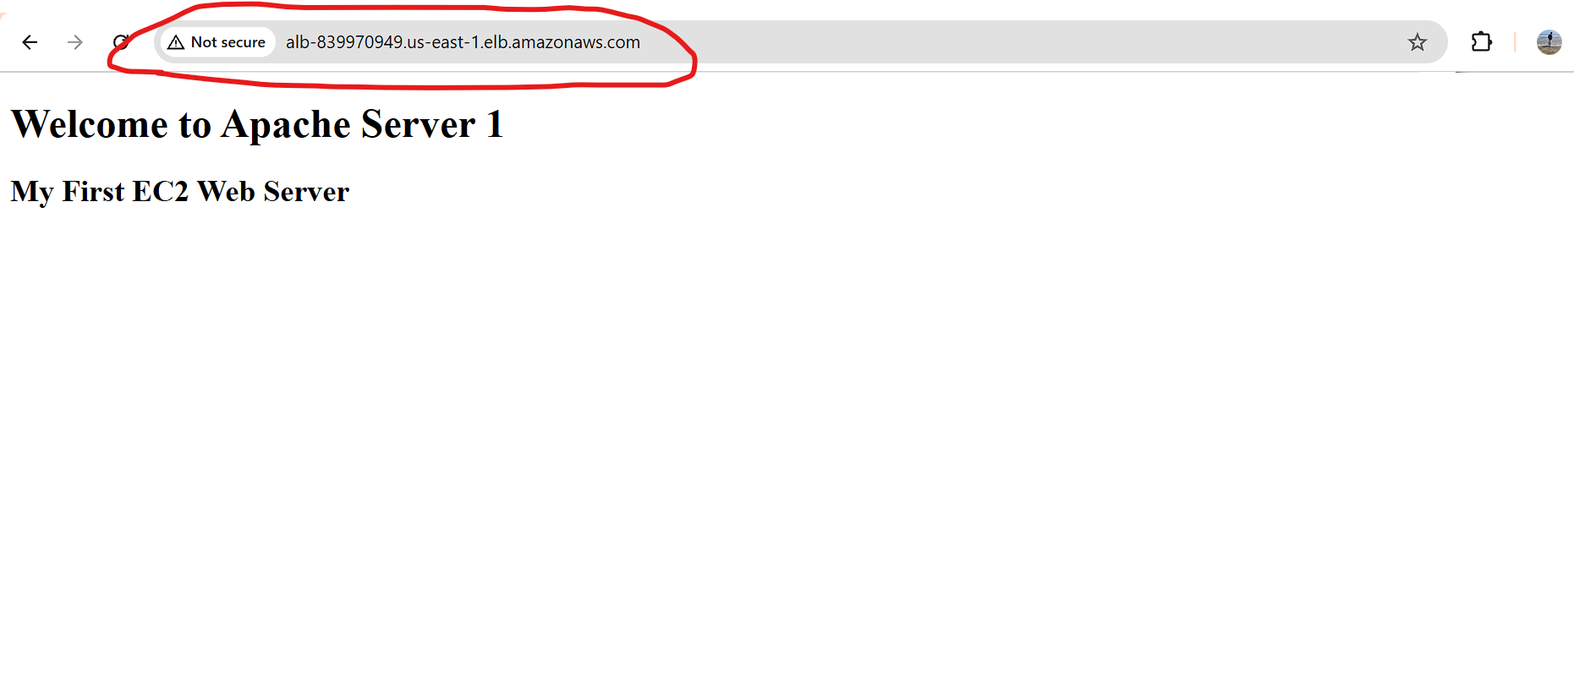
- Store application load balancer logs in S3.
We already configured alb. So, We need to create one bucket in S3.
Come to LB- select attributes tab- edit- In bottom will find access logs for S3-bucket name-save changes.
We can see the logs in S3 bucket.
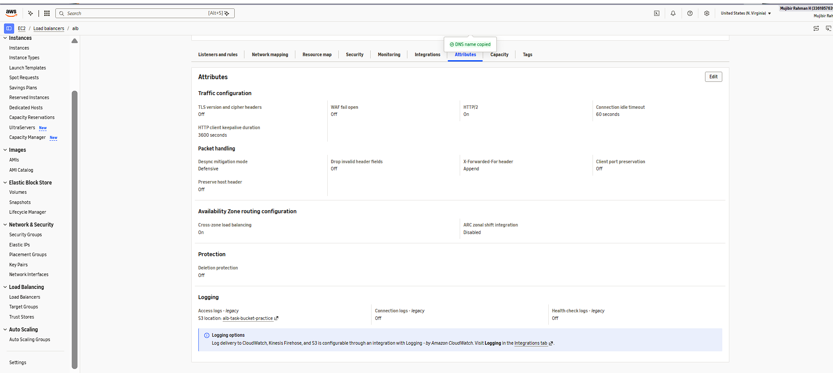
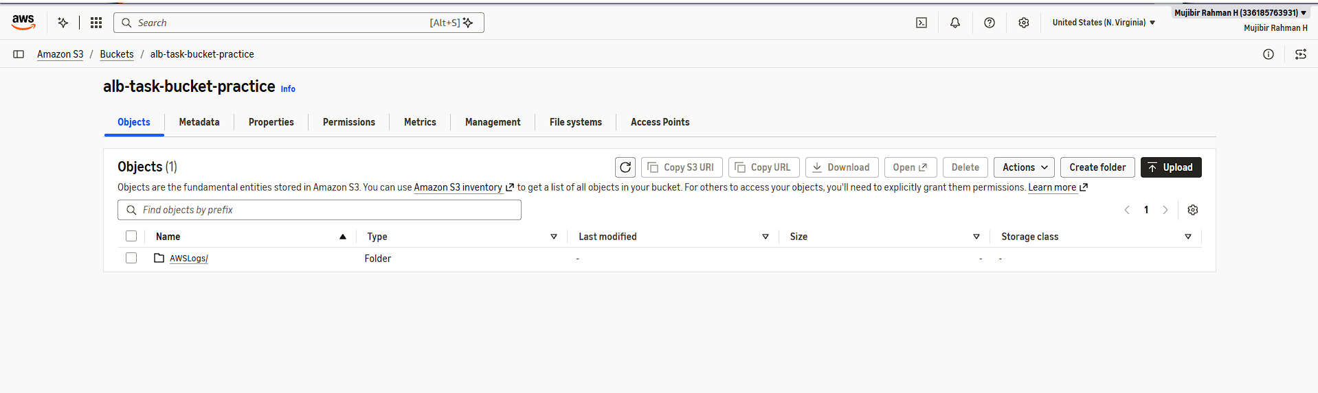
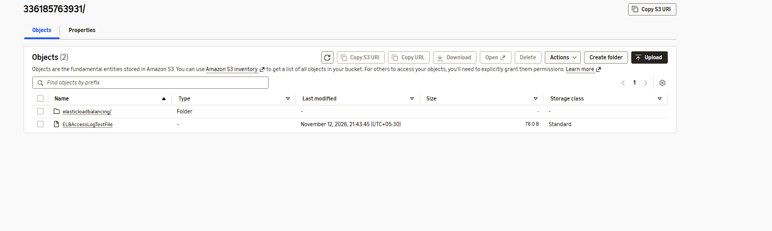
- Store the VPC flow logs in a CloudWatch log group.
I created the cloud watch Log group for storing the logs from VPC.
In VPC, Need to create the flow logs and select the destination path cloud watch.
We need to create IAM role and policy to contact other services in AWS.
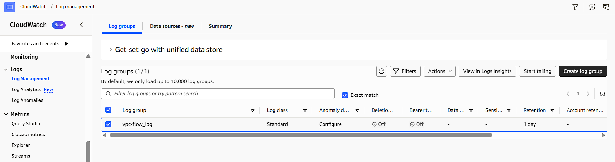
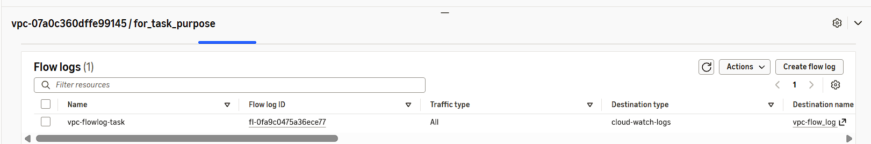
- Create monitoring dashboards to monitor CPU utilization and to monitor the Apache service.
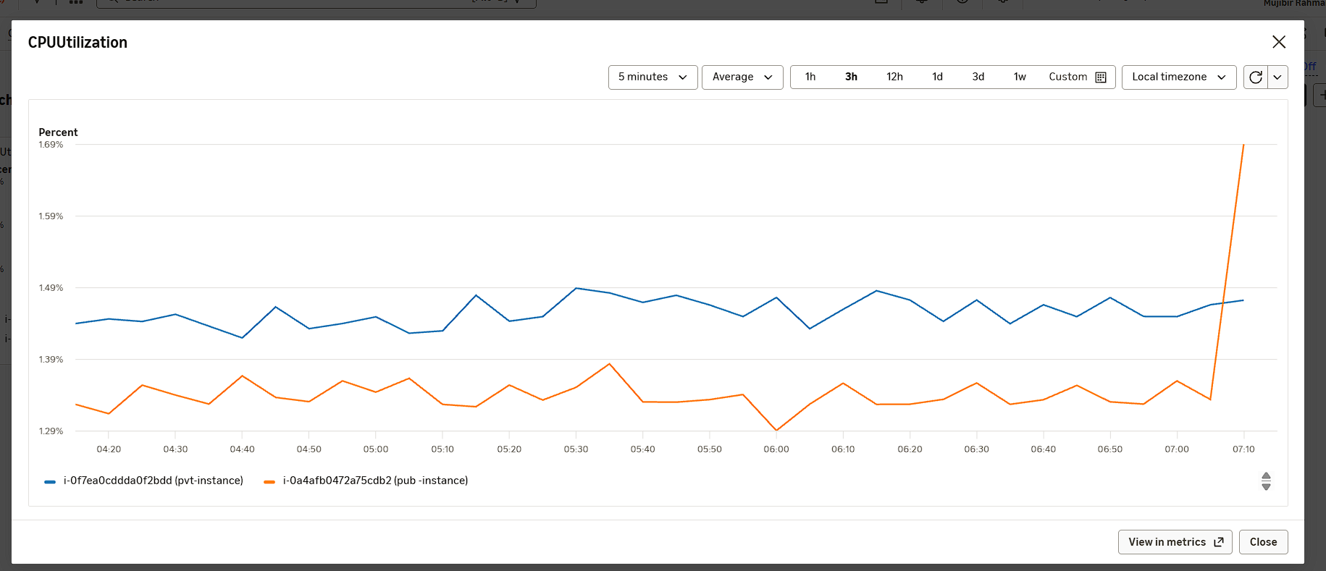
For this apache server montoring, we need to install cloud watch agent in both instances.
I created one more dashboard for monitor that server with appropriate metrics.
Prerequisite of this, We need to create an IAM role with policy cloud watch agent server policy and attach it to both instances.
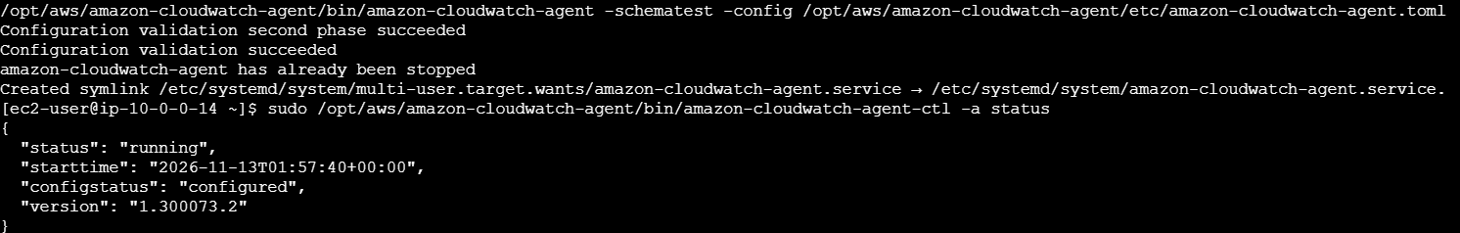
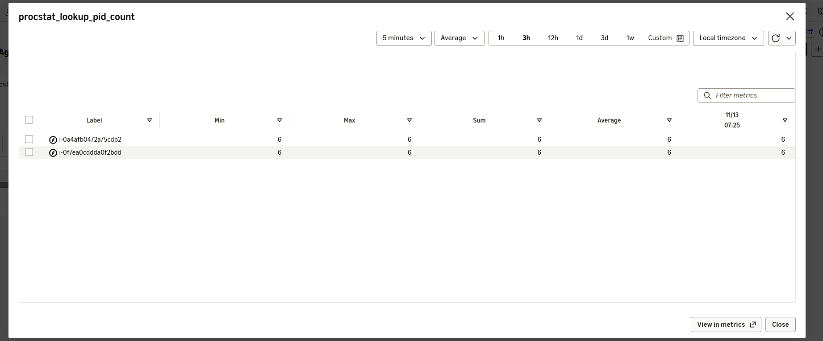
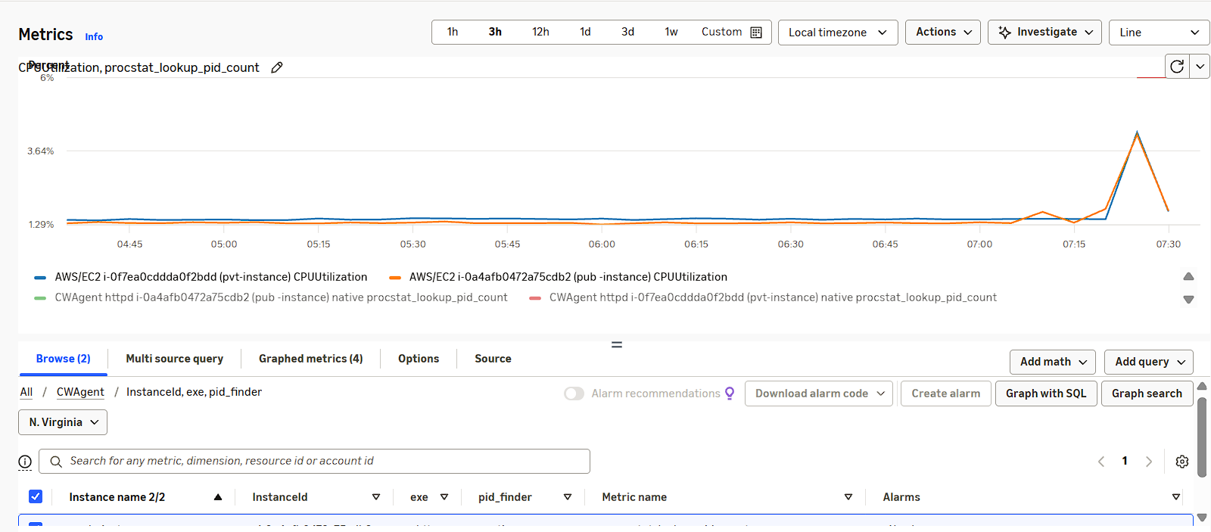
- If CPU utilization is more than 70%, then it should trigger auto scaling and launch new instance.
For auto scaling, we need to create the Launch template or launch configuration. Usually will go for launch template because we can modify that instantly and select the latest one.
After this, we need to create the auto scaling group.
For testing purpose, I put some stress on my instance. I am able to see autoscaling is working. Without any manual intervention ec2- instances are created.


